ISTANBUL
OFFICE REPORT
PRESS KIT
PRESS BULLETIN

CONTACT INFORMATION
2016
FOURTH QUARTER
Propin Property Investment Consultancy
Buyukdere Caddesi, Gokfiliz İs Merkezi
No. 8/22 F. 9 Mecidiyekoy, Istanbul
T +90 212 217 85 55
F +90 212 217 85 53
info@propin.com.tr | www.propin.com.tr

PROPIN PROPERTY INVESTMENT CONSULTANCY PRESS BULLETIN
03.02.2017
2016 FOURTH QUARTER ISTANBUL OFFICE MARKET GENERAL OVERVIEW
Propin, which offers Property Investment Consultancy service about leasing and purchase of offices areas and prepares a report on the Istanbul Office Market once in every three month; has released the report of the fourth quarter of 2016. It shows the changes that occurred in the office market during October, November and December and historical changes in office market in last ten years as well as shares Propin’s predictions for the upcoming periods.

Istanbul Office Market experienced a dull period in 2016.
In the report prepared, Propin indicated that the Istanbul Office Market experienced a dull period in 2016 due to economic and political issues in Turkey. It is said that continuing growth in stock increased the competitiveness in the market. It is also stated that the offers containing advantageous commercial conditions, alongside given rental discounts, caused negotiations to be completed rapidly.

Also in the report, it is informed that the total take-up volume in the Istanbul Office Market was 208,000 m² in 2016. It is said that the decline in total take-up volume, which started in 2015, continued in 2016 as well. It is emphasized that the total take-up volume in 2016 decreased 21% from 2015, and dropped drastically by 56% from 2014.

Take-up volume in the Central Business District (CBD) increased compared to previous year. Rental transactions and corporate purchases were generally in small and medium sized office areas.
In this report, Propin indicated that in 2016, the total take-up volume was 92,000 m² in the CBD and 44% of the take-up volume consisted of the completed transactions in this district. It is said that the total take-up volume in 2016 increased 18% from 2015.

In the report, it is mentioned that in 2016, when completed lease and purchase transactions are taken into the consideration in terms of size, it was observed that even the largest transactions were lower than 15,000 m². It is underlined that while transactions of office areas ranging in size from 1,001 m² to 5,000 m² constituted 50% of the completed transactions throughout the year, 1,000 m² sized and smaller offices made up 25% of the total take-up. It is said that it’s been monitored that these lease and purchase transactions carried out by the small and medium sized companies.

Class A office stock grew in Istanbul
In the report, Propin also declared that as of the end of 2016, Class A office stock in Istanbul increased to 4.7 million m². According to this data, it is informed that office stock in Istanbul increased 71% in the last quinquennium. It is indicated also that when stock data for the last quarter of 2016 is analyzed, that the Airport District has the largest stock volume in Istanbul can be seen. It is also stated that as new office buildings opened up to operation throughout the year, the Class A office stock in this district increased by 18% and surpassed 650,000 m². Maslak and Kozyatagi followed the Airport District in terms of the largest office stock as of 2016.

The vacancy rates for Class A office buildings increased in 2016.
In the report, it is mentioned that the vacancy rate for Class A office buildings in the CBD, which exhibited a drop at the beginning of 2016, started to rise after the second quarter. It is stated that increasing vacancy rate for Class A office buildings in the CBD throughout the last two quarters was observed as 25.7% for the last quarter of 2016. Also in the report, it is indicated that the vacancy rate for Class A office buildings, which was at 17.1% in Out of CBD-Asia in the first quarter of 2016, started to rise again after a decline in the second quarter. It is also informed that, in the fourth quarter of 2016, the vacancy rate for Class A office buildings in Out of CBD-Asia was seen at 19.7%.

Average rental rates generally decreased.
In the report prepared by Propin, it is stated that, tendency to decline was observed in average rental rate for Class A office buildings in the CBD e throughout 2016. It is informed that while average rental rate, which was $US 28.8 /m² /month in the first quarter of 2016, decreased to $US 27.6 /m² /month in the last one. It is emphasized that, throughout 2016, the average rental rate for Class A office buildings fell in Out of CBD-Asia. It is also underlined that the average rental rate, which was at a level of $US 20.1 /m² /month in the first quarter of 2016, ended up at a level of $US 18.5 /m² /month, decreasing by 8% at the end of 2016.

The summary of the report prepared by Propin “Istanbul Office Market in the fourth quarter of 2016” based on the latest data, is given below;

- The vacancy rate for Class A office buildings in the Central Business District (CBD) increased to 25.7%, and to 13.3% for Class B office buildings. The average rent for Class A office buildings in the CBD was US$ 27.6 /m² /month and $US 15.1 /m² /month for Class B office buildings.

- For Class A office buildings in Out of CBD-Europe, the vacancy rate was determined to be 24.2% and the average rent $US 17.1 /m² /month.

- The vacancy rate for Class A office buildings in Out of CBD-Asia was at a level of 19.7%. The average rent for Class A office buildings was $US 18.5 /m² /month.

- As in the previous quarters, Levent, located in the CBD, commanded the top prime rent In the fourth quarter of 2016. The listed prime rent was $US 54 /m² /month.

Levent was the district where the prime rent was set!

In the report that Propin has prepared, it is indicated that Levent was the district where the highest rent was demanded. It is said that, the figure was $US 45 /m² /month, as it was in the first three quarters of 2016. In the report, it is mentioned that Kozyatagi and Altunizade commanded the prime rent in Out of CBD-Asia at a level of $US 28 /m² /month.

2016 FOURTH QUARTER ISTANBUL OFFICE MARKET

GRAPHICS

03.02.2017

VACANCY RATES BY DISTRICT CATEGORY 2016 The Fourth Quarter 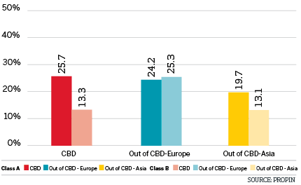

VACANCY RATES BY DISTRICT 2016 The Fourth Quarter

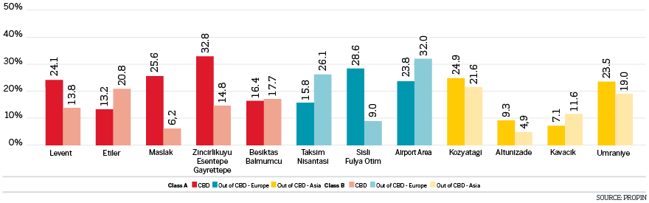

CHANGES IN VACANCY RATES OF CLASS A BUILDINGS The Last Four Quarters

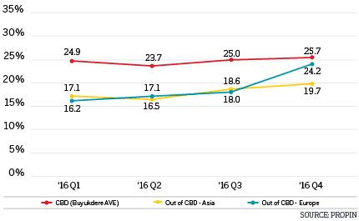

CHANGES IN VACANCY RATES OF CLASS B BUILDINGS The Last Four Quarters

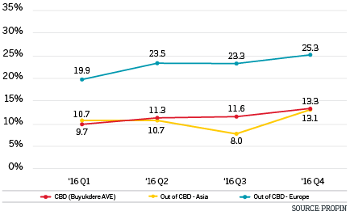

HISTORICAL VACANCY RATES OF CLASS A BUILDINGS 2007-2016 The Last Ten Years

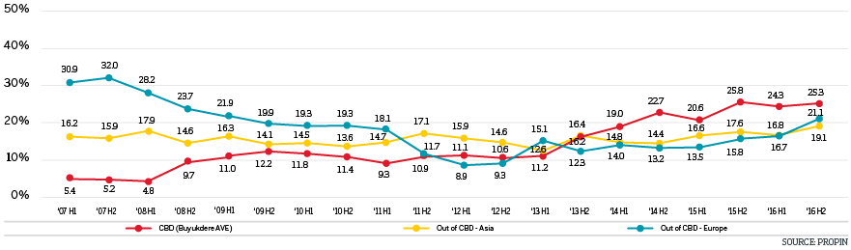

HISTORICAL VACANCY RATES OF CLASS B BUILDINGS 2007-2016 The Last Ten Years

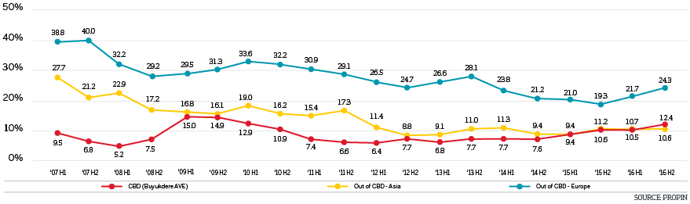

AVERAGE RENTAL RATES BY DISTRICT CATEGORY 2016 The Fourth Quarter

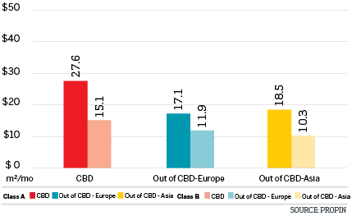

AVERAGE RENTAL RATES BY DISTRICT 2016 The Fourth Quarter

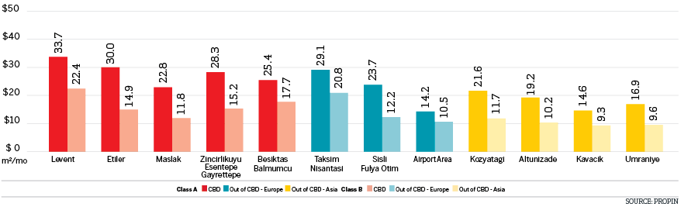

LISTING PRICES OF PRIME RENT BY DISTRICT IN ISTANBUL The Last Four Quarters

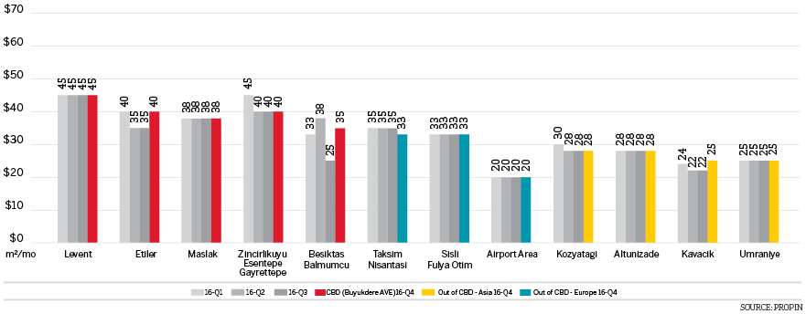

CHANGES IN AVERAGE RENTAL RATES OF CLASS A BUILDINGS The Last Four Quarters

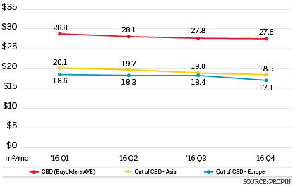

CHANGES IN AVERAGE RENT RATES OF CLASS B BUILDINGS The Last Four Quarters

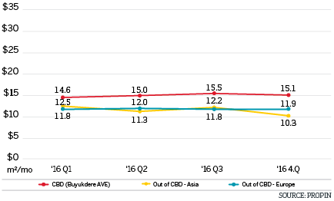

HISTORICAL AVERAGE RENT RATES OF CLASS A BUILDINGS 2007-2016 The Last Ten Years

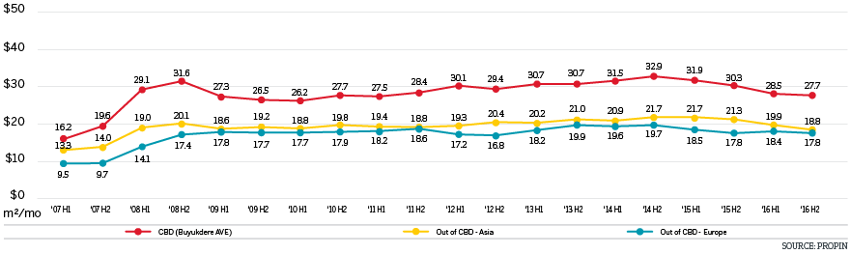

HISTORICAL AVERAGE RENT RATES OF CLASS B BUILDINGS 2007-2016 The Last Ten Years

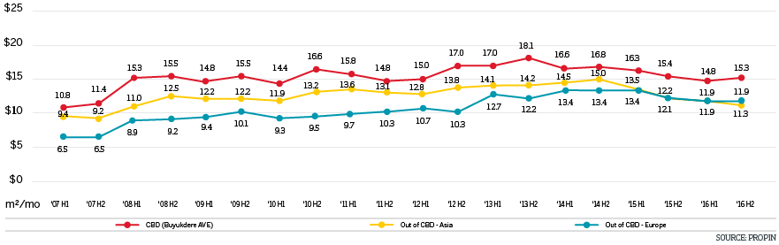

DISTRIBUTION OF CLASS A OFFICE STOCK BY DISTRICT CATEGORY 2016 The Fourth Quarter

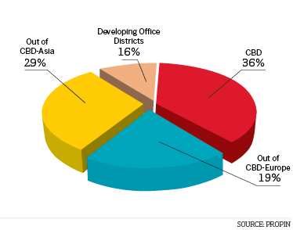

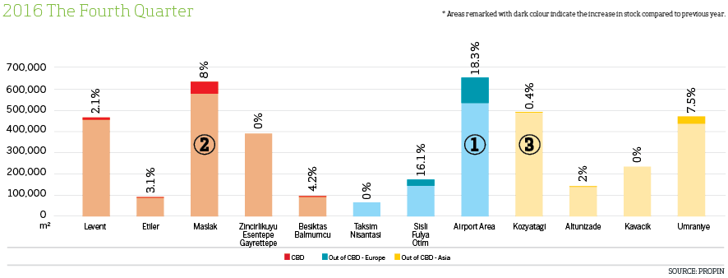
DISTRIBUTION OF CLASS A OFFICE STOCK BY DISTRICT 2016 The Fourth Quarter
Areas remarked with dark colour indicate the increase in stock compared to previous year.

ANNUAL GROWTH IN STOCK OF CLASS A BUILDINGS BY YEAR 2008-2020

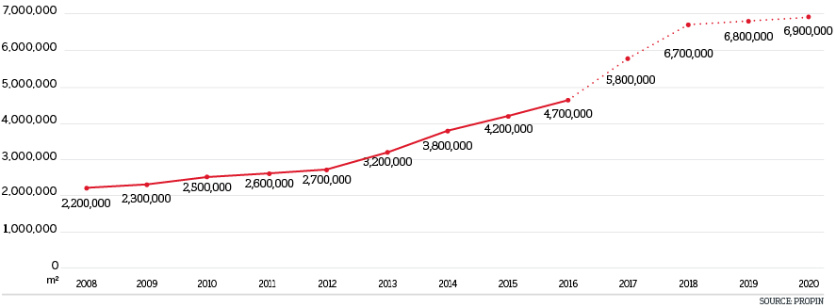

ANNUAL VOLUME OF OFFICE STOCK BY DISTRICT CATEGORY 2008-2020

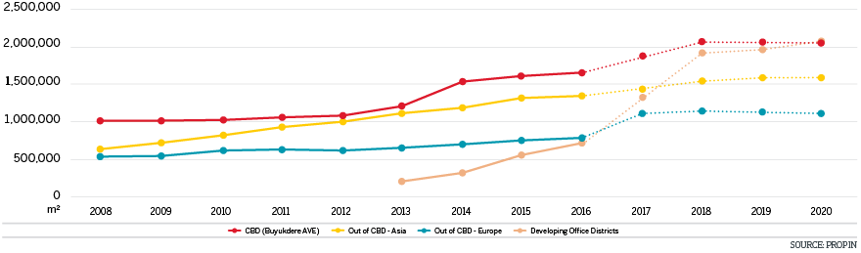

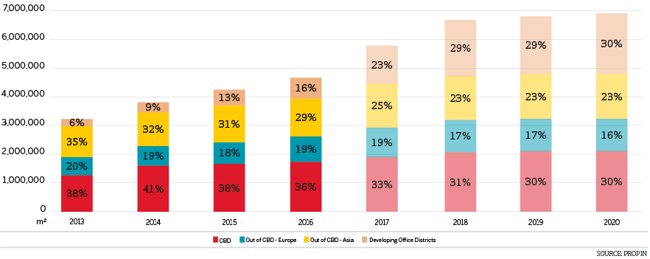

TAKE-UP VOLUME 2008-2016

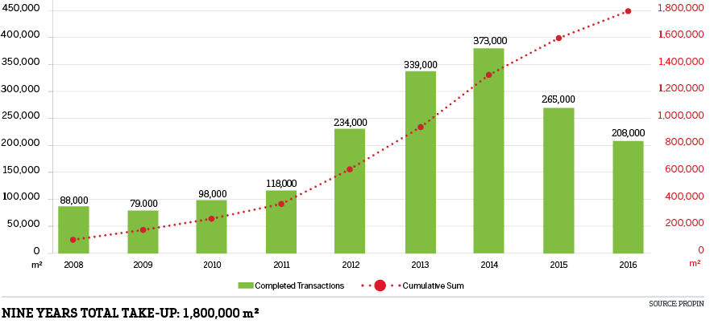

TAKE-UP DISTRICBUTION BY DISTRICT CATEGORY 2016

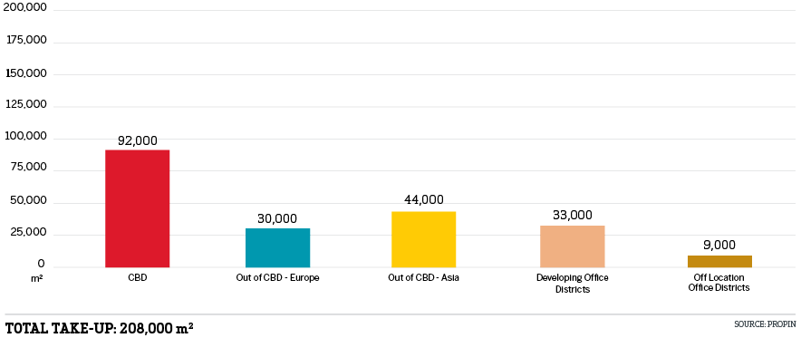

EDITOR’S NOTE: Propin Property Investment Consultancy is a commercial property investment consultancy company specializing in the “office” sector. Propin provides advisory and agency services to property users, landlords and property investors. The company’s service covers Istanbul and other metropolises where the office market is developing.
Founded in 2005, Propin has made an impact in the sector within a short period of time, exemplified by its quality of work and service. Obvious indicators of its success are the references from the most prestigious Turkish and global companies. Propin, with a quality and productivity accompanied by expertise, provides a full range of service to its customers in the office market. From its inception, its guiding principle has been to never make concessions on business ethics. It gives importance to trust that has been built up in the sector and strives to maintain that trust in the future.
www.propin.com.tr | info@propin.com.tr

