ISTANBUL
OFFICE REPORT
PRESS KIT
PRESS BULLETIN

CONTACT INFORMATION
2017
FOURTH QUARTER
Propin Property Investment Consultancy
Eski Buyukdere Avenue. Humeyra St.
Nef Offices 09 Block B No 7 Floor 5/114
34400, 4.Levent/ Istanbul
T +90 212 217 85 55
F +90 212 217 85 53
info@propin.com.tr | www.propin.com.tr

PROPIN PROPERTY INVESTMENT CONSULTANCY PRESS BULLETIN
02.02.2018
2017 FOURTH QUARTER ISTANBUL OFFICE MARKET GENERAL OVERVIEW
Propin, which offers Property Investment Consultancy service about leasing and purchase of offices areas and prepares a report on the Istanbul Office Market once in every three month; has released the report of the fourth quarter of 2017. It shows the changes that occurred in the office market during October, November and December and historical changes in office market in last ten years as well as shares Propin’s predictions for the upcoming periods.

Istanbul Office Market saw a dynamic period in 2017.
In the report prepared, Propin declared that, the fourth quarter of 2017 in the Istanbul Office Market was a period in which the commercial conditions of offices turned out to the office user’s advantage even further. It is detailed that, the reason for this advantageous commercial conditions was based on an ongoing increase in stock, negativity stemming from financial conditions, and fluctuations in the exchange rate.

Also in the report, it is informed that, the total amount of commercial leasing or purchasing transaction size was recorded as 359,000 m² in the Istanbul office areas. It is reminded that, the transaction volume, which had declined in 2015, declined even further in 2016. It is emphasized that, the reason behind the 72% rise in transaction volume in 2017 compared to the previous year was the improved financial conditions for tenants. It is said that, even though 2017 was more hectic than 2015 and 2016. It is underlined that, the vacancy rate in Class A Office buildings in the CBD hit a record high in last ten years with a rate of 31.4%.

In 2017, transactions were mainly took place in large scale office areas in Istanbul Office Market. Purchasing transactions were less than rental transactions in the Market.
In this report, Propin indicated that, the number of transactions for large scale office users and investors was remarkable in 2017 in the Istanbul Office Market. It is informed that, while 10,000 m² and larger-sized transactions constituted 29% of the total volume in the market. It is stated that, the share of transactions between 5,001 and 10,000 m²-sized was 16%. It is said that, advantages such as granted leasing discounts, the change of the currency of transactions to Turkish Lira, and long rent-free terms played key roles in office areas’ being leased more aggressively.

In the report, it is stated that in 2017, the leasing and purchasing transaction volume in the CBD increased 24% from 2016. It is indicated that transaction size was measured at 114,000 m² in the CBD. It is said that, in Ferko Signature, where PROPIN is the landlord representative, a 9,300 m2-sized block being leased by Yemek Sepeti was the biggest transaction completed in Levent in 2017. Moreover, it is informed that an increase in the interest of office users and investors towards the Developing Office Districts in 2017 was observed. It is underlined that, with the impact of architectural features that cover user demands and advantageous leasing conditions, a total of 91,000 m² in leasing and purchasing agreements were executed in the Developing Office Districts. It is emphasized that, the transaction in which Is Yatirim Bosphorus Capital acquired the 24,680 m²-sized Nidakule Atasehir West Building in West Atasehir was the biggest purchasing transaction.

In the report that prepared, it is stated that In spite of this, the total amount of sales was way behind the total amount of leases, as always. It is mentioned that, a total amount of 60,000 m² commercial purchases were completed in 2017. It is indicated that, approximately 55% of this total was executed in Out of CBD-Asia and the Developing Office Districts in Asia. It is said that, another significant transaction carried out on the Asian side was Schindler’s 3,500 m²-sized purchase, mediated by PROPIN, in Agaoglu My Newwork in West Atasehir.

In 2017, Class A office stock grew in Istanbul.
In the report, Propin also declared that, although political and economic events throughout 2016 and 2017 led to the postponement of the opening dates of previously launched projects in the Istanbul Office Market. It is said that, by end of 2017, the Istanbul Office Stock reached 5,700,000 m². It is stated that, after the completion and coming into service of recent office investments, office stock of the Airport District drew near 850,000 m². It is informed that, the Airport District, which soared by 22% in one year in terms of stock. It is informed that, the Airport District stood out as the biggest office district in Istanbul, as it was in 2016.

The vacancy rates for Class A office buildings increased in the CBD; decreased in Out of CBD-Europe and Out of CBD-Asia.

In the report, it is reminded that, the vacancy rate for Class A office buildings in the CBD witnessed an upward trend during 2017. It is indicated that, the vacancy rate, 27.7% in the first quarter of 2017. It is stated that, the vacancy rate climbed to 31.8% in the fourth quarter of 2017. It is underlined that, increases in stock in Maslak and Levent played particularly crucial roles in the 15% vacancy rate rise in Class A office buildings in the CBD. It is also informed that, the vacancy rate for Class A office buildings in Out of CBD-Asia was 20.6% in the first quarter of 2017. It is stated that, throughout the first three quarters of 2017, this level was maintained. It is said that, the vacancy rate for Class A office buildings in Out of CBD-Asia slumped to 19.7% in the fourth quarter of 2017.

Average rental rates generally decreased in 2017.

In the report prepared by Propin, it is said that, the average rental rate for Class A office buildings in the CBD average rental rate for Class A office buildings in the CBD declined by 7.9% over the four quarters. It is stated that, the average rate was at $US 24.8 /m² /month in the last quarter of the year. It is informed that, in Out of CBD-Asia, the average rental rate for Class A office buildings fluctuated during 2017. It is emphasized that, the average rental rate, which was $US 18.4 /m² /month at the beginning of the year. It is underlined that the average rental rate fell to $US 17.5 /m² /month in the fourth quarter.
The summary of the report prepared by Propin “Istanbul Office Market in the fourth quarter of 2017” based on the latest data, is given below;

- The vacancy rate for Class A office buildings in the Central Business District increased to 31.8% and to 15.2% for Class B office buildings. The average rent for Class A office buildings in the CBD was $US 24.8 /m² /month, and $US 13 /m² /month for Class B office buildings.

- For Class A office buildings in Out of CBD-Europe, the vacancy rate was determined to be 21.4% and the average rent was $US 15.2 /m² /month.

- The vacancy rate for Class A office buildings in Out of CBD-Asia was at a level of 19.7%. The average rent for Class A office buildings was $US 17.5 /m² /month.

- Levent, located in the CBD, was the district where the prime rent rate was asked. The listed prime rent was $US 44 /m² /month in this district.

Levent was the district where the prime rent was set!

In the report that Propin has prepared, it is indicated that In the fourth quarter of 2017, Levent was the district where the highest rent was demanded. It is stated that, as it was in the third quarter, the highest listing price asked in Levent was observed to be $US 44 /m² /month in the last quarter of 2017. In the report, it is said that, Kozyatagi commanded the top prime rent in Out of CBD-Asia. It is declared that, the prime rent in this district was $US 28 /m² /month in the fourth quarter of 2017.

2017 FOURTH QUARTER ISTANBUL OFFICE MARKET

GRAPHICS

02.02.2018

VACANCY RATES BY DISTRICT CATEGORY 2017 The Fourth Quarter

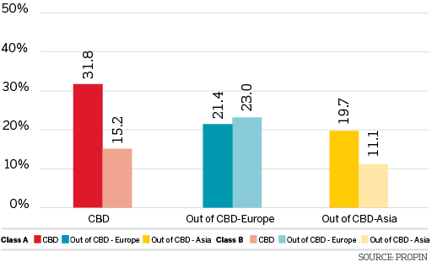

VACANCY RATES BY DISTRICT 2017 The Fourth Quarter

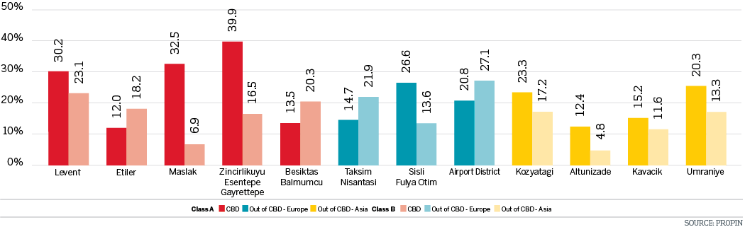

CHANGES IN VACANCY RATES OF CLASS A BUILDINGS The Last Four Quarters

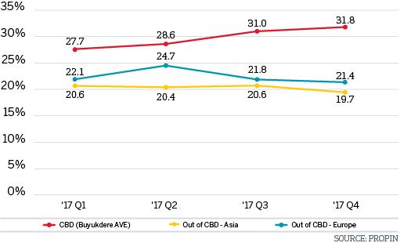

CHANGES IN VACANCY RATES OF CLASS B BUILDINGS The Last Four Quarters

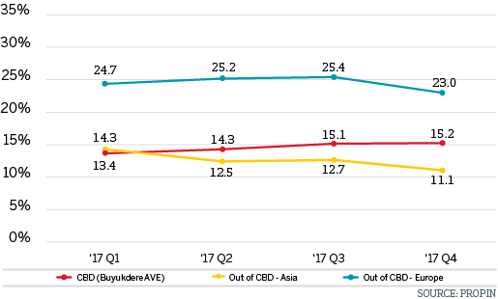

HISTORICAL VACANCY RATES OF CLASS A BUILDINGS 2008-2017 The Last Ten Years

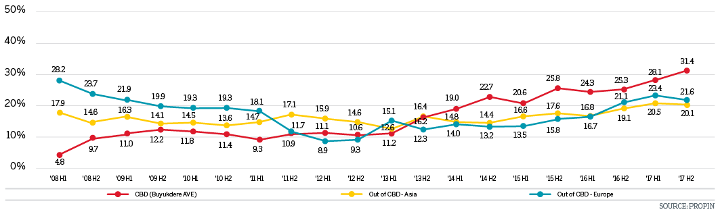

HISTORICAL VACANCY RATES OF CLASS B BUILDINGS 2008-2017 The Last Ten Years

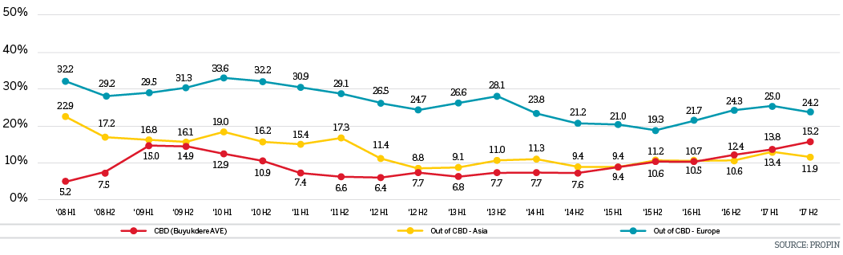

AVERAGE RENTAL RATES BY DISTRICT CATEGORY 2017 The Fourth Quarter

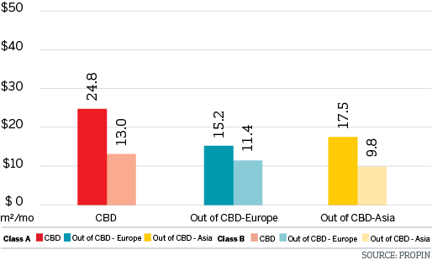

AVERAGE RENTAL RATES BY DISTRICT 2017 The Fourth Quarter

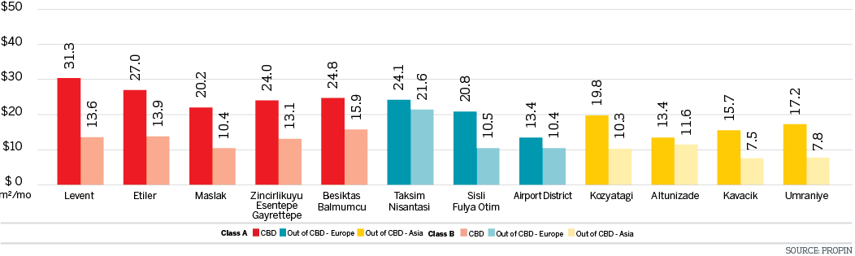

LISTING PRICES OF PRIME RENT BY DISTRICT IN ISTANBUL The Last Four Quarters

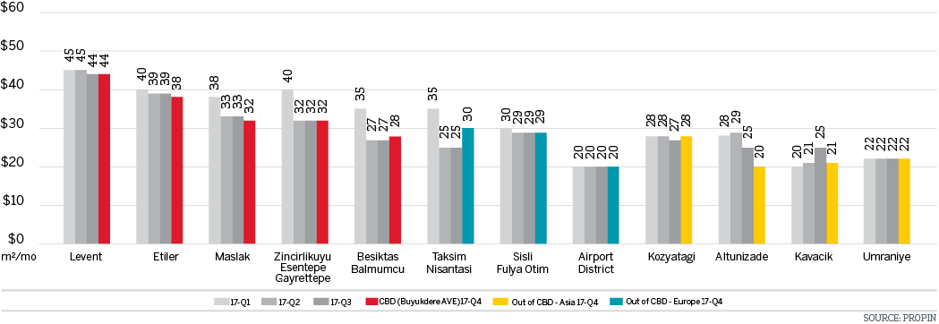

CHANGES IN AVERAGE RENTAL RATES OF CLASS A BUILDINGS The Last Four Quarters

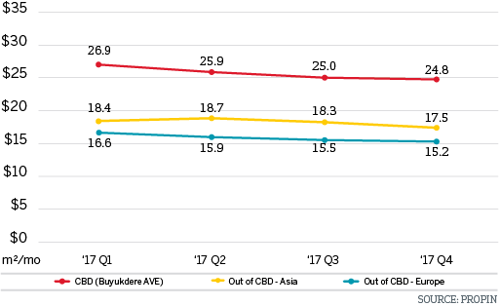

CHANGES IN AVERAGE RENT RATES OF CLASS B BUILDINGS The Last Four Quarters

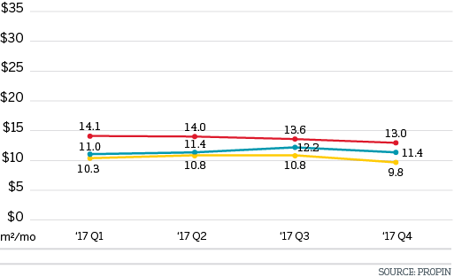

HISTORICAL AVERAGE RENT RATES OF CLASS A BUILDINGS 2008-2017 The Last Ten Years

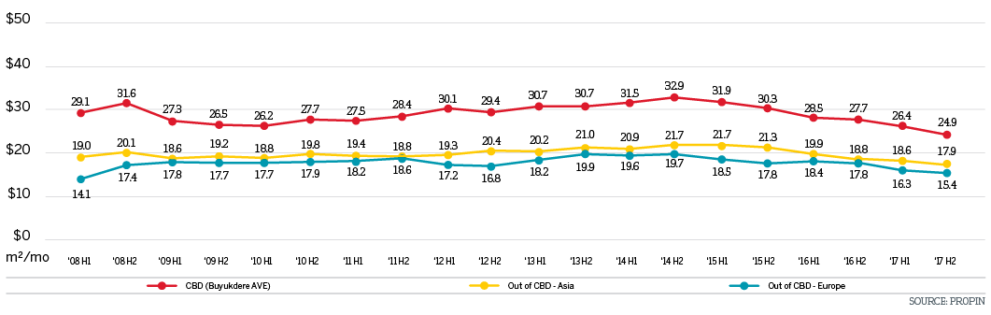

HISTORICAL AVERAGE RENT RATES OF CLASS B BUILDINGS 2008-2017 The Last Ten Years

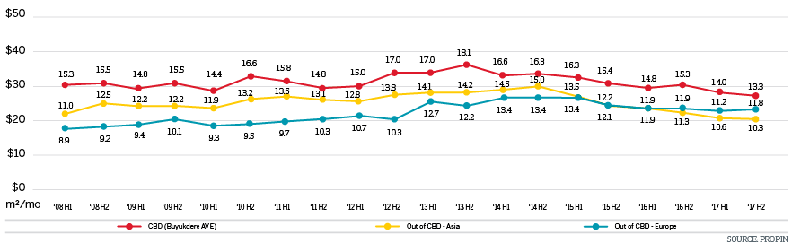

DISTRIBUTION OF CLASS A OFFICE STOCK BY DISTRICT CATEGORY 2017 The Fourth Quarter

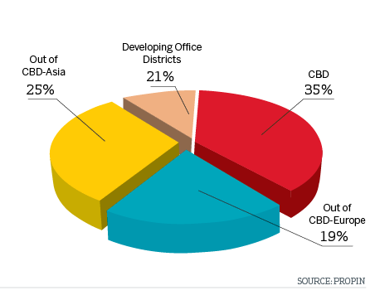

DISTRIBUTION OF CLASS A OFFICE STOCK BY DISTRICT 2017 The Fourth Quarter

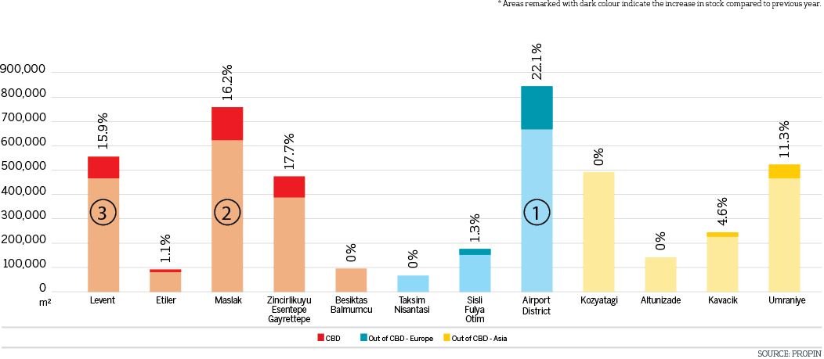

ANNUAL GROWTH IN STOCK OF CLASS A BUILDINGS BY YEAR 2008-2021

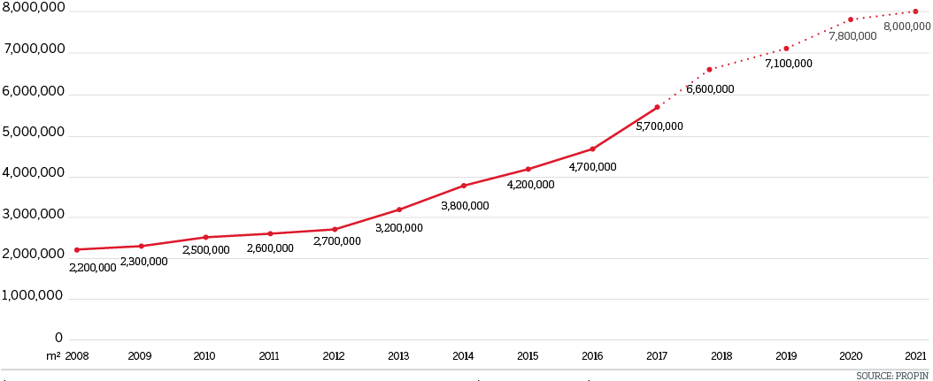

ANNUAL VOLUME OF OFFICE STOCK BY DISTRICT CATEGORY 2008-2021

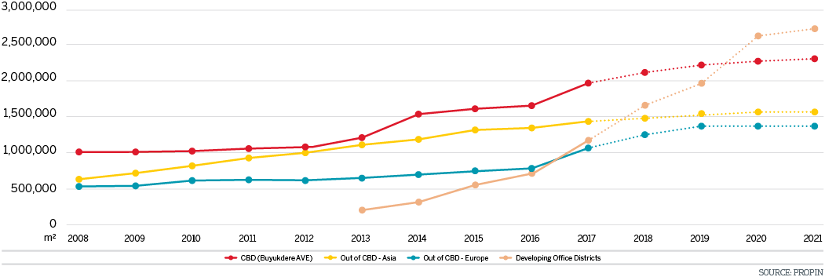

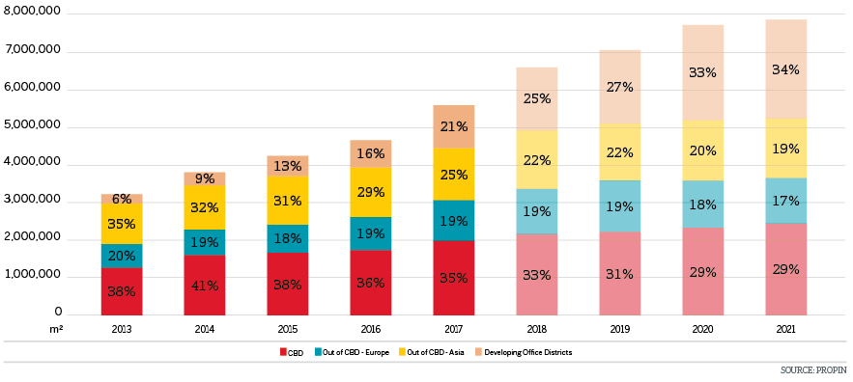

TAKE-UP VOLUME 2008-2017

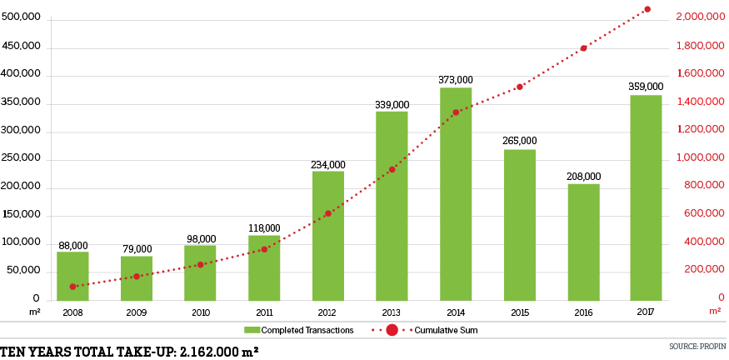

TAKE-UP DISTRICBUTION BY DISTRICT CATEGORY 2017

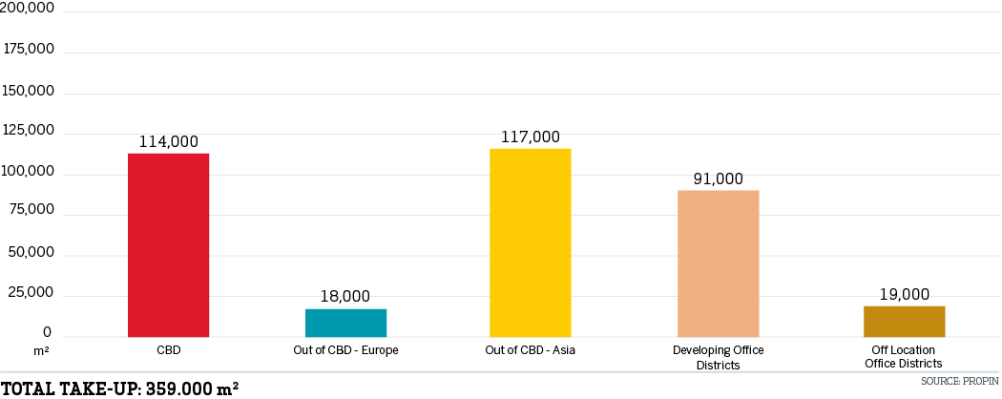

EDITOR’S NOTE: Propin Property Investment Consultancy is a commercial property investment consultancy company specializing in the “office” sector. Propin provides advisory and agency services to property users, landlords and property investors. The company’s service covers Istanbul and other metropolises where the office market is developing.
Founded in 2005, Propin has made an impact in the sector within a short period of time, exemplified by its quality of work and service. Obvious indicators of its success are the references from the most prestigious Turkish and global companies. Propin, with a quality and productivity accompanied by expertise, provides a full range of service to its customers in the office market. From its inception, its guiding principle has been to never make concessions on business ethics. It gives importance to trust that has been built up in the sector and strives to maintain that trust in the future.
www.propin.com.tr | info@propin.com.tr

