ISTANBUL
OFFICE REPORT
PRESS KIT
PRESS BULLETIN

CONTACT INFORMATION
2017
SECOND QUARTER
Propin Property Investment Consultancy
Buyukdere Caddesi, Gokfiliz İs Merkezi
No. 8/22 F. 9 Mecidiyekoy, Istanbul
T +90 212 217 85 55
F +90 212 217 85 53
info@propin.com.tr | www.propin.com.tr

PROPIN PROPERTY INVESTMENT CONSULTANCY PRESS BULLETIN
27.07.2017
2017 SECOND QUARTER ISTANBUL OFFICE MARKET GENERAL OVERVIEW
Propin, which offers Property Investment Consultancy service about renting and acquisition of offices, prepares a report on the Istanbul Office Market every three month; the report of the second quarter of 2017 has just been released. It shows the changes that occurred in the office market during April, May, and June as well as shares Propin’s predictions of Propin for the upcoming periods.

Istanbul Office Market passed a hectic period in the second quarter of 2017.
In the report, Propin announced that, in the second quarter of 2017 was a hectic period for Istanbul Office Market. Propin stated that, as the consequence of increasing competition in the market, landlords tended to decrease listing prices and provide financially more suitable terms and this situation enabled big number of leasing transactions to be completed in the second quarter of 2017. It is said that, on the other hand, since some international companies in Turkey went downsizing, they reduced the amount of office area they used. It is indicated that these office areas caused vacancy rates to increase.

Istanbul office stock grew.
In the report, Propin wrote that, Istanbul Class A office stock grew in the second quarter of 2017. Propin said that Nidakule Levent in Levent and Kosifler Plaza in Kavacik were the buildings added to Istanbul office stock in the second quarter of 2017. In addition to them, Propin indicated that, stock increase has also observed in Airport District which already has the biggest stock in Istanbul. Propin announced that when total stock in the second quarter of 2017 is taken into the account, it’s been observed that stock share of the CBD, Out of CBD-Europe, Out of CBD-Asia and Developing Office Districts [Kagithane, Bomonti-Piyalepasa, Kartal-Maltepe, West Atasehir] was measured as 37%, 20%, 28% and %15 respectively.

Vacancy Rate increased in the CBD and in Out Of CBD-Europe but was stable in Out of CBD-Asia.
In the report, one can say that in the CBD, the vacancy rate for Class A office buildings in the CBD has increased throughout the last four quarters. It is stated that, the vacancy rate for Class A office buildings in the CBD increased to 28.6% in the second quarter of 2017. It is underlined that, the increasing stock throughout last four quarters in Levent and Zincirlikuyu-Esentepe-Gayrettepe was the major factor in this uptick. Besides, it is informed that, throughout last four quarters, vacancy rates for Class A office buildings in Out of CBD-Europe fluctuated. In the report it is also reminded that, in Out of CBD-Asia, the vacancy rare for Class A office buildings was measured at 18.6% in the third quarter of 2016. It is stated that, vacancy rate that started to show tendency to increase as of the last quarter of 2016, remained stable compared to previous quarter at the level of 20.4% in the second quarter of 2017.

Average rental rates decreased in the CBD and in out of CBD-Europe, yet increased in Out of CBD-Asia
In the report prepared by Propin, it is reminded that, the average rent rate for Class A office buildings in the CBD was static during the last two quarters of 2016. It is said that, the average rent rate for Class A office buildings in the CBD that started to demonstrate a downward trend as of 2017, determined to be $US 25.9 /m² /month in the second quarter of 2017. In the report, it is emphasized that the average rent rate of Class A office buildings, which was $US 18.4 /m² /month in the third quarter of 2016, slipped to a level of $US 15.9 /m² /month in Out of CBD-Europe. Moreover, it is informed that, while the average rental rate for Class A office buildings in Out of CBD-Asia remained at the same level as it was the previous quarter, it soared up to
$US 18.7 /m² /month.

The summary of the report prepared by Propin “Istanbul Office Market in the second quarter of 2017” based on the latest data, is given below;

- While the vacancy rate for Class A office buildings in the Central Business District (CBD) was 28,9%, it was measured at 14.3% in Class B office buildings. The average rent for Class A office buildings in the CBD was $US 25.9 /m2 /month and $US 14 /m2 /month for Class B office buildings.

- The vacancy rate for Class A office buildings in Out of CBD-Europe was determined to be at a level of 22.1% and the average rent for Class A office buildings was $US 15.8 /m2 /month.

- For Class A office buildings in Out of CBD-Asia, the vacancy rate was at a level of 20.4%. The average rent for Class A office buildings was $US 18.7 /m2 /month.

- The prime rent for Istanbul Office Market was commended by Levent, located in CBD, in the second quarter of 2017. The requested figure was $US 45 /m2 /month.

Levent was the district where the prime rent was set!

In the report that Propin has prepared, it is said that, Levent was the district where the highest rent was demanded in Istanbul in the second quarter of 2017. It is revealed that, it had been in previous quarters, prime rent in Levent was determined to be $US 45 /m2 /month in the second quarter of 2017. In the report, it is stated that, Sisli-Otim-Fulya commanded the top prime rent ($US 29 /m² /month) in Out of CBD-Europe in the second quarter of 2017. Moreover, it is mentioned that, Altunizade was the district where prime rent was asked in Out of CBD-Asia. It is stated that, demanded rent was measured at $US 29 /m² /month in this district.

2017 SECOND QUARTER ISTANBUL OFFICE MARKET - GRAPHICS

27.07.2017

VACANCY RATES BY DISTRICT CATEGORY 2017 The Second Quarter

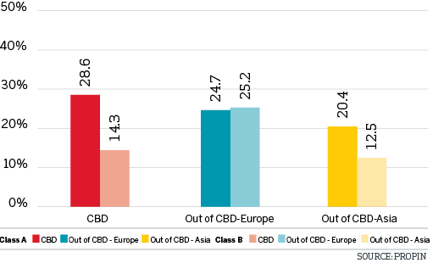

VACANCY RATES BY DISTRICT 2017 The Second Quarter

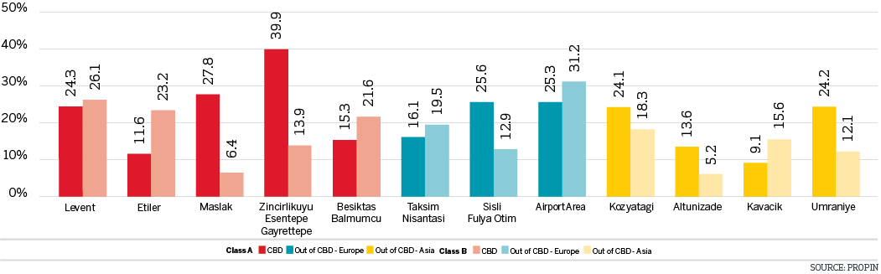

CHANGES IN VACANCY RATES OF CLASS A BUILDINGS The Last Four Quarters

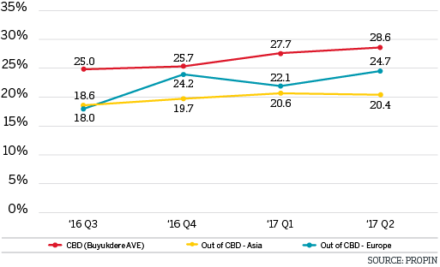

CHANGES IN VACANCY RATES OF CLASS B BUILDINGS The Last Four Quarters

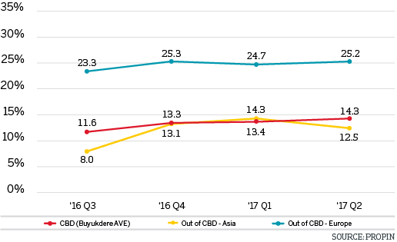

AVERAGE RENTAL RATES BY DISTRICT CATEGORY 2017 The Second Quarter

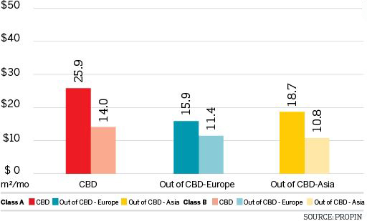

AVERAGE RENTAL RATES BY DISTRICT 2017 The Second Quarter

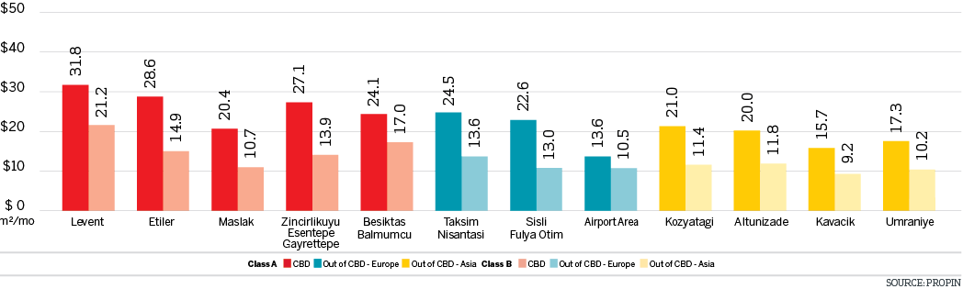

LISTING PRICES OF PRIME RENT BY DISTRICT IN ISTANBUL The Last Four Quarters

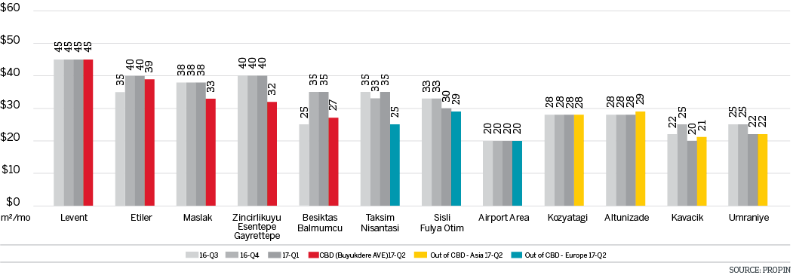

CHANGES IN AVERAGE RENTAL RATES OF CLASS A BUILDINGS The Last Four Quarters

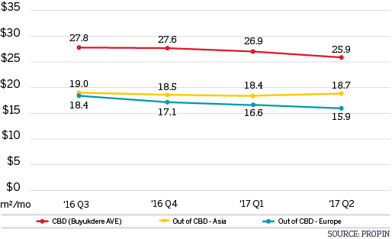

CHANGES IN AVERAGE RENT RATESOF CLASS B BUILDINGS The Last Four Quarters

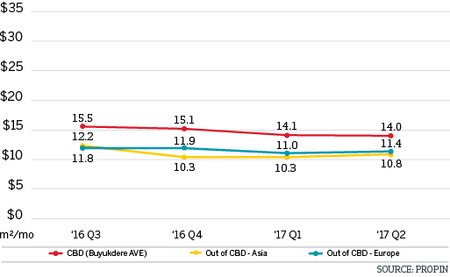

CLASS A STOCK COMPARISON OF THE ISTANBUL OFFICE DISTRICTS

DISTRIBUTION OF CLASS A OFFICE STOCK BY DISTRICT CATEGORY 2017 The Second Quarter

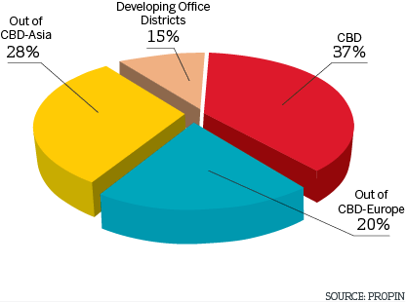

DISTRIBUTION OF CLASS A OFFICE STOCK BY DISTRICT 2017 The Second Quarter

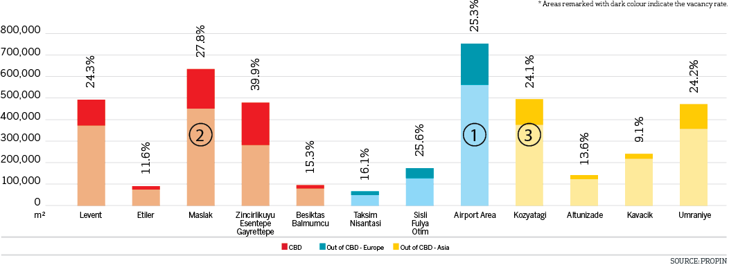

EDITOR’S NOTE: Propin Property Investment Consultancy is a commercial property investment consultancy company specializing in the “office” sector. Propin provides advisory and agency services to property users, landlords and property investors. The company’s service covers Istanbul and other metropolises where the office market is developing.
Founded in 2005, Propin has made an impact in the sector within a short period of time, exemplified by its quality of work and service. Obvious indicators of its success are the references from the most prestigious Turkish and global companies. Propin, with a quality and productivity accompanied by expertise, provides a full range of service to its customers in the office market. From its inception, its guiding principle has been to never make concessions on business ethics. It gives importance to trust that has been built up in the sector and strives to maintain that trust in the future.
www.propin.com.tr | info@propin.com.tr

