ISTANBUL
OFFICE REPORT
PRESS KIT
PRESS BULLETIN

CONTACT INFORMATION
2018
FIRST QUARTER
Propin Property Investment Consultancy
Eski Büyükdere Cd. Hümeyra Sok.
Nef Offices 09 B Blok No 7 Kat 5/114
34400, 4.Levent/ İstanbul
T +90 212 217 85 55
F +90 212 217 85 53
info@propin.com.tr | www.propin.com.tr

PROPIN PROPERTY INVESTMENT CONSULTANCY PRESS BULLETIN
04.05.2018
ISTANBUL OFFICE MARKET GENERAL OVERVIEW 2018 FIRST QUARTER
“Istanbul Office Market General Overview 2018 First Quarter Report” which is prepared by PROPIN Property Invesment Consultancy every three month, has just been released. PROPIN which offers agency and advisory services about “offices” in commercial real estate sector, analyzed the changes that occurred in the office market during the first quarter of 2018 and predictions for the upcoming periods.

THE NEGOATITION PERIOD IN ISTANBUL OFFICE MARKET
In the Istanbul Office Market General Overview 2018 First Quarter Report by Propin, it is mentioned that discounts in listing prices left their mark in the office market.

Propin emphasized In the report that, the approximate 8% decline in average rent rate in the Class A office buildings in the Central Business District (CBD) was remarkable. Propin said that, the first quarter of 2018 was a period when hard bargains between landlords and potential tenants were observed. Propin mentioned that, due to the general economic conjuncture of Turkey, it was seen that the companies have started to negotiate with landlords even before expiration of their contract. It is conveyed that, at the same time, pursuit of office areas with financially more reasonable terms negotiated began for some companies.

In the report, Propin underlined that, the effects of the fluctuations in the economy, as well as the devaluation of the Turkish Lira (TL) against foreign currencies, were noticed in the Istanbul Office Market, just like other sectors. It is stated that, discounts in listing prices and changes in terms in favor of tenants in the office market. It is said that, the pressure to sign contracts in Turkish Lira affected the market in the first quarter of 2018.

THE SLOWDOWN IN OFFICE DEVELOPMENT
In the report, Propin evaluated the stock increase in the Istanbul Office Market. Propin explained that, no change in stock was observed in the Central Business Districts. It is mentioned that, however office investments continued in the Developing Office Districts.

Propin emphasized that, announced launching dates were postponed. It is explained that, experienced landlords who have full knowledge of the competitive terms in the market did not accelerate the construction processes for the office areas they develop until they across a demand.

Propin conveyed that, as for total stock size reached in the fırst quarter of 2018, the stock share of the CBD, Out of CBD-Europe, Out of CBD-Asia and Developing Office Districts (Kagithane, Bomonti-Piyalepasa, Kartal-Maltepe, West Atasehir) was measured at 35%, 19%, 24%, and 22% respectively.

VACANCY RATE OF OFFICES INCREASED IN THE LAST YEAR
PROPIN in the Istanbul Office Market General Overview Report 2018 First Quarter Report determined that the vacancy rates of the Class A office buildings in the Central Business District increased. It is emphasized that, throughout the last four quarters, one could see a 10.5%increase in Class A office buildings in the CBD. It is stated that, between the second quarter of 2017 and the first quarter of 2018, a decline was seen in the vacancy rate for Class A office buildings in Out of CBD-Europe. It is said that, the vacancy rate for Class A office buildings in Out of CBD-Europe was determined to be 21.6% in the first quarter of 2018. It is informed that, the vacancy rate for Class A office buildings in Out of CBD-Asia fluctuated between 19% and 21% over last four quarters.

THE OFFICE RENTS DECREASED 8% IN ISTANBUL
In the Istanbul Office Market General Overview 2018 First Quarter Report PROPIN explained that, the average rent rate for Class A office buildings in the CBD declined 8.1% during the period between the second quarter of 2017 and the first quarter of 2018.

The summary of “Istanbul Office Market General Overview 2018 First Quarter Report” prepared by Propin based on the latest data, is given below;

- While the vacancy rate for Class A office buildings in the Central Business District (CBD) was 31.6%, it was measured at 12.9% in Class B office buildings. The average rent for Class A office buildings in the CBD was $US 23.8 /m² /month and $US 12.3 /m² /month for Class B office buildings.

- The vacancy rate for Class A office buildings in Out of CBD-Europe was determined to be 21.6% and the average rent for Class A office buildings was measured at $US 15.3 /m² /month.

- For Class A office buildings in Out of CBD-Asia, the vacancy rate was 19.4% and the average rent for Class A office buildings was $US 17.4 /m² /month.

- The top prime rent -$US 44 /m² /month- was observed in the CBD in Levent, in the first quarter of 2018

THE PRIME RENT IN LEVENT
In the report that Propin has prepared, it is mentioned that, Levent was the district where the highest rent was demanded in Istanbul in the first quarter of 2018. It is said that, the highest rent rate was $US 44 /m² /month, as it had been in the last two quarters. In the report, it is also stated that, in the first quarter of 2018, top prime rent in Out of CBD-Europe was asked in Taksim-Nisantasi. It is revealed that, top prime rent asked in this district was at a level of $US 30 /m² /month. It is said that, top prime rent in Out of CBD-Asia, $US 27 /m² /month, was demanded in Kozyatagi in the first quarter of 2018.
ISTANBUL OFFICE MARKET 2018 FIRST QUARTER - GRAPHICS
04.05.2018

VACANCY RATES BY DISTRICT CATEGORY 2018 The First Quarter

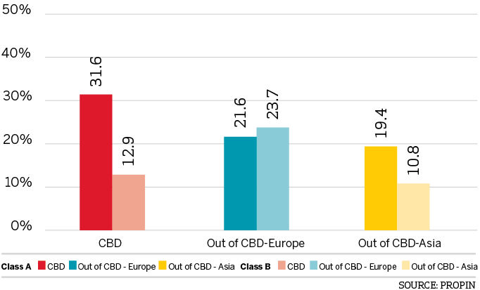

VACANCY RATES BY DISTRICT 2018 The First Quarter

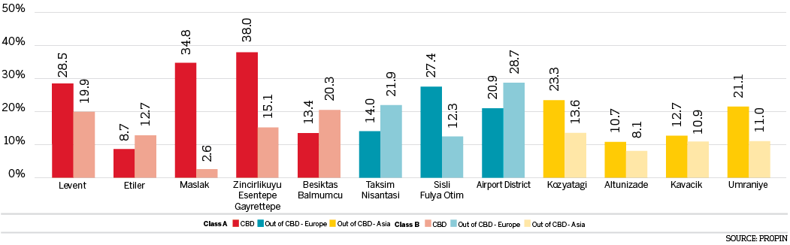

CHANGES IN VACANCY RATES OF CLASS A BUILDINGS The Last Four Quarters

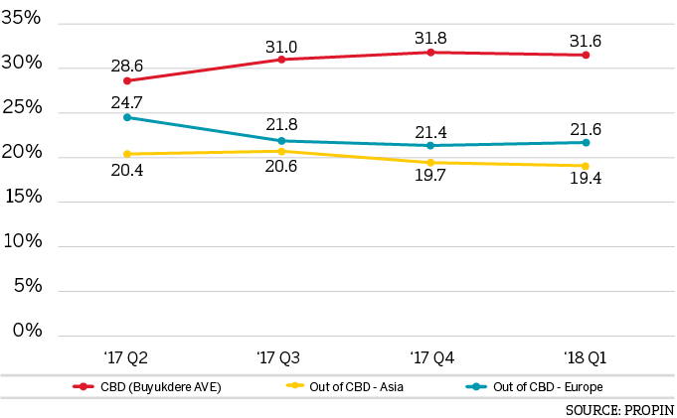

CHANGES IN VACANCY RATES OF CLASS B BUILDINGS The Last Four Quarters

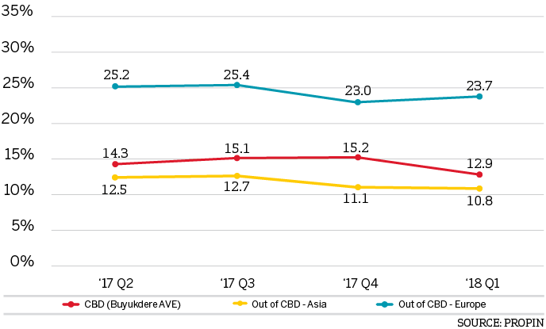

AVERAGE RENTAL RATES BY DISTRICT CATEGORY 2018 The First Quarter

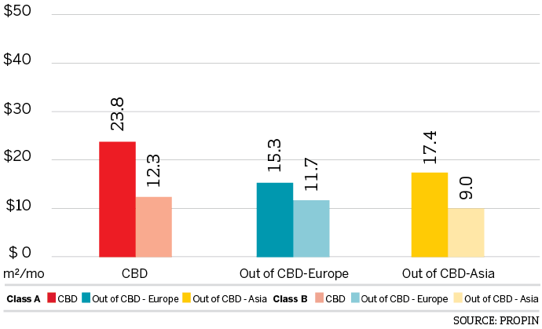

AVERAGE RENTAL RATES BY DISTRICT 2018 The First Quarter

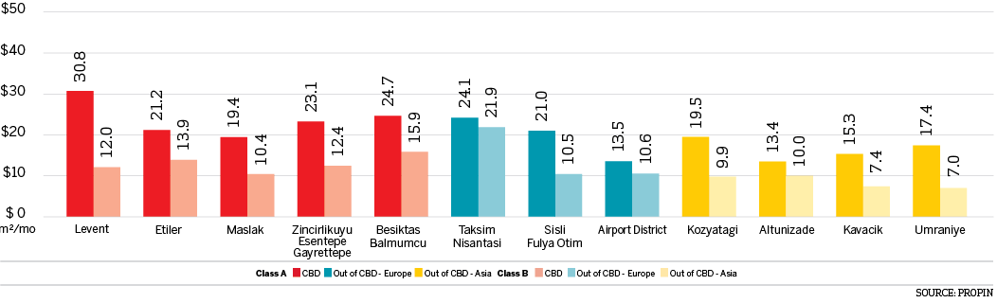

LISTING PRICES OF PRIME RENT BY DISTRICT IN ISTANBUL The Last Four Quarters

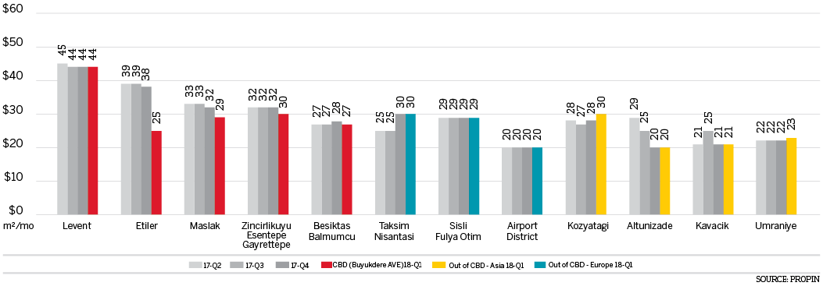

CHANGES IN AVERAGE RENTAL RATES OF CLASS A BUILDINGS The Last Four Quarters

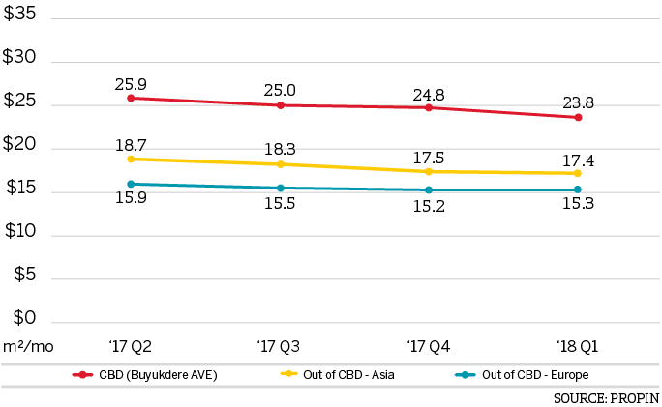

CHANGES IN AVERAGE RENT RATESOF CLASS B BUILDINGS The Last Four Quarters

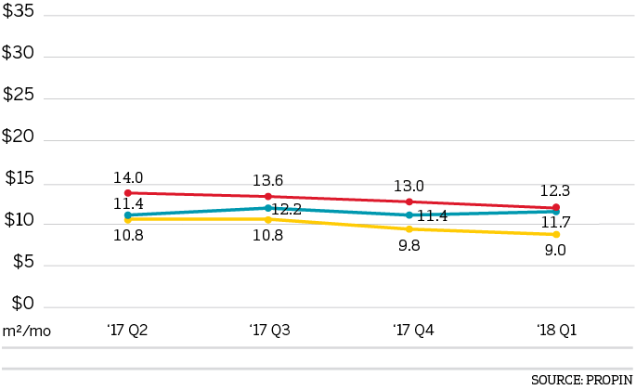

DISTRIBUTION OF CLASS A OFFICE STOCK BY DISTRICT CATEGORY 2018 The First Quarter

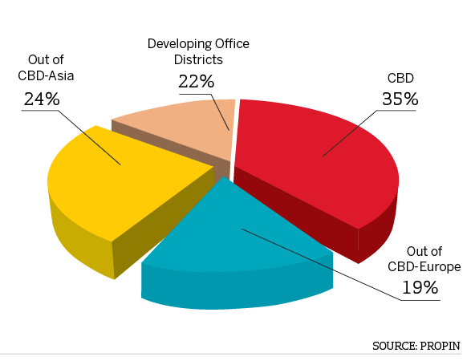

DISTRIBUTION OF CLASS A OFFICE STOCK BY DISTRICT 2018 The First Quarter

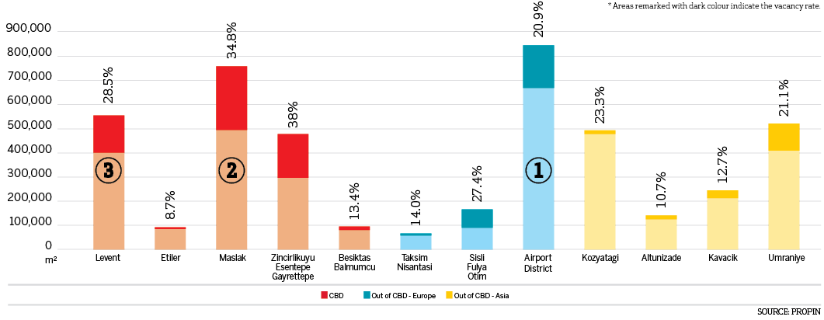

EDITOR’S NOTE: Propin Property Investment Consultancy is a commercial property investment consultancy company specializing in the “office” sector. Propin provides advisory and agency services to property users, landlords and property investors. The company’s service covers Istanbul and other metropolises where the office market is developing.
Founded in 2005, Propin has made an impact in the sector within a short period of time, exemplified by its quality of work and service. Obvious indicators of its success are the references from the most prestigious Turkish and global companies. Propin, with a quality and productivity accompanied by expertise, provides a full range of service to its customers in the office market. From its inception, its guiding principle has been to never make concessions on business ethics. It gives importance to trust that has been built up in the sector and strives to maintain that trust in the future.
www.propin.com.tr | info@propin.com.tr

